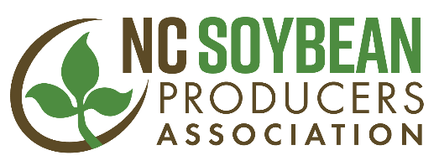
For Immediate Release Contact: Jeff Jennings Jan.15, 2018 (919) 839-5700

NORTH CAROLINA SOYBEAN PRODUCERS ASSOCIATION ELECTS NEW MEMBERS TO BOARD OF DIRECTORS
RALEIGH, N.C. – The North Carolina Soybean Producers Association elected seven new members to serve a three-year term on its board of directors at its 51st annual meeting in Durham, N.C. on Jan. 12, 2018. Five members were elected to serve a second term on the board of directors.
Directors on the state soybean board are responsible for overseeing the soybean checkoff-funded research, marketing and communications work of the association, as well as conducting advocacy work on behalf of the state’s soybean industry.
Newly elected board members are:
Name/Hometown Counties Represented
Reggie Baker, Monroe, N.C. Gaston, Mecklenburg, Union
Angela Bergen, Pantego, N.C. Bertie, Chowan, Dare, Tyrell, Washington
Andy Bland, Dover, N.C. Bladen, Brunswick, Columbus, New Hanover, Pender
Ray Bullard, Stedman, N.C. Cumberland, Harnett
Aaron Kirk, Hillsborough, N.C. Alamance, Caswell, Durham, Forsyth, Granville, Guilford, Orange, Person, Rockingham, Stokes
Trey Liverman, Columbia, N.C. Bertie, Chowan, Dare, Tyrell, Washington
Kevin Matthews, East Bend, N.C. Alleghany, Ashe, Buncombe, Burke, Caldwell, Cherokee, Clay, Graham, Haywood, Henderson, Jackson, McDowell, Macon, Madison, Mitchell, Polk, Rutherford, Surry, Transylvania, Watauga, Wilkes, Yadkin, Yancey

The following directors were elected to serve a second term:
Director Counties Represented
Sydney Edwards Dunn of Edenton, N.C. Johnston
Greg Manning of Nashville, N.C. Edgecombe, Halifax, Nash
Philip Sloop of Mt. Ulla, N.C. Alexander, Catawba, Cleveland, Davie, Davidson, Iredell, Lincoln, Randolph, Rowan
Jason Starnes of Salisbury, N.C. Alexander, Catawba, Cleveland, Davie, Davidson, Iredell, Lincoln, Randolph, Rowan
Reggie Strickland of Mt. Olive, N.C. Duplin
North Carolina soybean producers elected the following officers for 2018: President, John Fleming of Scotland Neck, N.C.; Vice President, Jeff Tyson of Nashville, N.C.; Secretary, David Heath of Dover, N.C. and Treasurer, Jeff Peed of Aurora, N.C.
For more information, call Jeff Jennings, chief executive officer of the North Carolina Soybean Producers Association at (919) 839-5700.
The North Carolina Soybean Producers Association is a statewide trade association representing all North Carolina soybean producers, responsible for research, education and promotion programs to benefit the state’s soybean farmers. The association is the qualified state board responsible for administering national soybean checkoff programs in North Carolina. The association is the state affiliate of the American Soybean Association (ASA).
###

