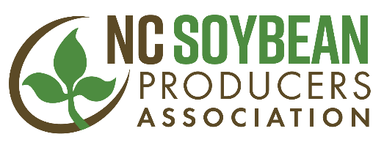

For Immediate Release Contact: Jeff Jennings Jan. 15, 2018 (919) 839-5700

STATE SOYBEAN ASSOCIATION SERVICE AWARD NAMED IN HONOR OF DR. JIM DUNPHY OF N.C. STATE UNIVERSITY; DUNPHY NAMED FIRST RECIPENT

RALEIGH, N.C. – The Meritorious Service Award given annually by the North Carolina Soybean Producers Association to recognize someone in the agriculture industry who made an outstanding contribution to the soybean industry in the state has been renamed the Dr. Jim Dunphy Soybean Industry Award in honor of Dunphy, professor of crop science and soybean extension specialist at N.C. State University. The announcement was made Jan. 11, 2018, at the annual banquet of the N.C. Commodities Conference in Durham, N.C., where Dunphy was also named the first recipient of the award. John Fleming, president of the North Carolina Soybean Producers Association, presented the award.
Dunphy, who will retire in Apr. 2018, received the award for his dedicated service to N.C. soybean growers over his 42-year career at N.C. State. In his role as soybean extension specialist, Dunphy helped North Carolina growers improve their efficiency, productivity and yields. During his tenure, the average soybean yield in N.C. increased 52.5% from 23.8 bushels per acre in 1970-1974 to 36.3 bushels per acre in 2012-2016.
Dunphy resides in Raleigh with his wife Judy. He received a bachelor of science in Ag Science and Master of Science in Soil Fertility from the University of Illinois, and has a doctorate in Soil Fertility from Iowa State University. He worked at Iowa State as an extension crop production specialist before beginning work at N.C. State in 1975.
For more information call Jeff Jennings, chief executive officer of the North Carolina Soybean Producers Association at (919) 839-5700.
The North Carolina Soybean Producers Association is a statewide trade association representing all North Carolina soybean producers, responsible for research, education and promotion programs to benefit the state’s soybean farmers. The association is the qualified state board responsible for administering national soybean checkoff programs in North Carolina. The association is the state affiliate of the American Soybean Association (ASA.)

###

